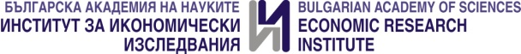

Jubilee scientific conference 2024
Dedicated to the 75th Anniversary of the Economic Research Institute at BAS

Economic development and policies:
realities and perspectives
EUROPEAN INTEGRATION, CONVERGENCE AND COHESION
25 November 2024, Sofia
application form
Names, scientific degree and academic position of author/s:
1.
2.
3.
Affiliation of author/s:
1.
2.
3.
Title of the paper:
Abstract (up to 10 lines):
Keywords:
JEL:
How you will participate (bold your answer):
- Online  - In person | - Presentation only  - With presentation and full text of the paper for publication

Please send your application not later than 30 September 2024!

