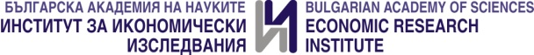

International scientific conference
Dedicated to the 70th Anniversary of the Economic Research Institute at BAS

Economic development and policies:
realities and perspectives

21-22 November 2019, Sofia

application form

Names, scientific degree and academic position of author/s:
1.
2.
3.

Institution of author/s:
1.
2.
3.

Title of paper:

Abstract (up to 10 lines):

Thematic area:

Form of participation:
- Paper
- Poster

Please send your application not later than 30th September 2019!

